Ideation Phase
Empathize & Discover

Date | 02 NOVEMBER 2025
Team ID | NM2025TMID02363
Project Name | Laptop Request Catalog Item
Maximum Mark | 4 Marks

Empathy Map Canvas
In the Empathize & Discover phase, the team observed how employees interact with the laptop request process. Through interviews and feedback sessions, they discovered that users often feel confused, frustrated, and uncertain during the request journey. The lack of dynamic guidance, unclear field requirements, and absence of real-time updates leads to delays and incomplete submissions.
By empathizing with users, the team identified key pain points:
- Users don’t know which laptop type suits their role.
- They’re unsure what justification is expected.
- They receive no confirmation or status updates after submitting the form.
- IT admins struggle with inconsistent data and manual tracking.
These insights helped shape a solution that is intuitive, responsive, and transparent — improving both user experience and backend efficiency.

Empathy Map Keywords
Profile – Employee
Lifecycle – Request → Approval → Delivery
User – Staff needing laptops
Assignment – Laptop type, justification
Ownership – IT Admin, Manager
Status – Pending, Approved, Delivered
Risk – Delays, incomplete data
Empathy Map – Think, Feel, Say, Do
Trigger – Need for laptop
Audit Trail – Request history
Prevention – Form validation
Compliance – Approval workflow
System Control – UI Policies
Policy – Role-based access
Integrity – Accurate data
Workflow – Request routing
Rules – Mandatory fields
Validation – Dynamic checks
Example: Laptop Request vs. Online Train Ticket Booking
Just like booking a train ticket online, where users face confusion with seat selection, payment failures, and lack of confirmation, employees experience similar challenges when requesting laptops:
.
Think & Feel | “I need a laptop urgently, but I don’t know which model to choose.”  “Will my request go through or get rejected?”
Hear | “Make sure you fill all fields correctly.”  “Approval might take time.”
See | A static form with no guidance, no preview of laptop specs
Say & Do | Ask colleagues for help, submit incomplete forms, follow up manually
Pain | Delays, rejections, no confirmation, unclear approval process
Gain | Guided form, dynamic fields, instant confirmation, clear approval tracking

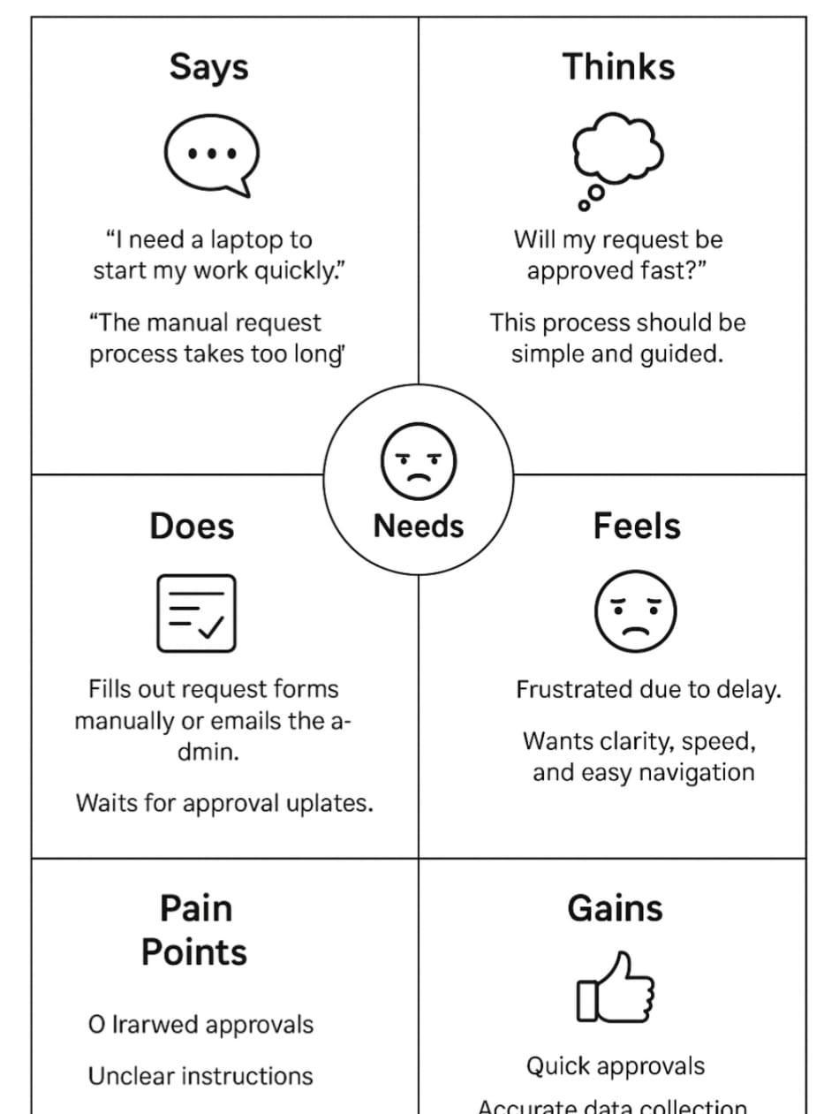
Empathy Map Summary
By deeply understanding the users through empathy mapping, we identified the critical frustrations in the laptop request process. These include:
- Lack of guidance on form fields
- No real-time feedback or status updates
- Uncertainty about approval criteria
As a result, we designed a smarter Service Catalog item that:
- Uses UI Policies to guide users dynamically
- Includes reset and submit buttons for ease of use
- Sends automated notifications for approvals and delivery
- Tracks requests for audit and governance
This solution improves accuracy, reduces delays, and builds user confidence in the system

